Fig Bruschetta with Cambozola Honey
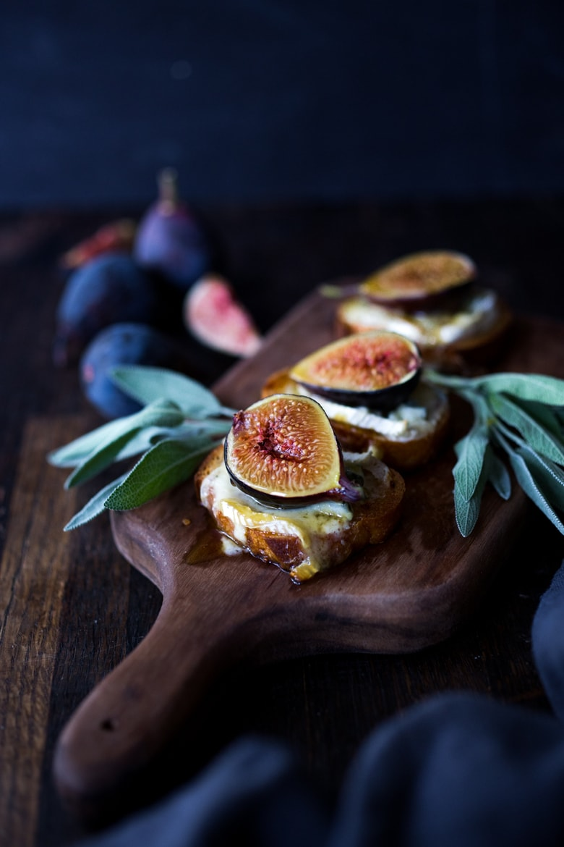
DESCRIPTION:
Fig Bruschetta with Cambozola Cheese and sage honey– a simple appetizer highlighting fresh figs that can be served warm or room temperature.

INGREDIENTS:
1 baguette, sliced
olive oil for brushing (or use spray olive oil)salt
12 figs, halved
12 ounces cambazola cheese ( or sub double cream gorganzola)
Sage Honey:
1/2 cup honey
4 tablespoons water
6–8 fresh sage leaves ( or sub 3 rosemary sprigs or thyme sprigs)
Balsamic Glaze for drizzling.
Cook Mode Prevent your screen from going dark

INSTRUCTIONS:
Preheat oven to 400.
Make the Sage honey: Place all ingredients into a small pot. Heat over low heat, stirring, until hot, turn heat off. You could do this ahead for maximum sage flavor ( Just leave on your counter, remove sage before using.)
Make the Bruschetta: Slice baguette into 1/3 inch thick slices. Place on a sheet pan and light brush or spray both sides with olive oil. You should have about 24 slices. Sprinkle with salt. Bake until crisp, golden and fragrant, about 20 mintues.
Assemble: Slice the cambazola into thin slices, including the skin, and place a small slice ( 1 inch by 2 inches) on each bruschetta. Top with half a fig. Drizzle with the sage honey and sprinkle with cracked pepper and salt.
Place on a platter and serve at room temp, or place it back into the warm oven to melt the cheese a bit, ( 10-15 mintues) then platter and serve warm.
Drizzle with a balsamic glaze if you like.

NUTRITION:
Calories: 154Sugar: 9.8 g
Sodium: 347.7 mg
Fat: 5.2 g
Saturated Fat: 2.8 g
Carbohydrates: 22.1 g
Fiber: 1.5 g
Protein: 5.8 g
Cholesterol: 10.6 mg

